**GESTURE SPEAK: SIGN LANGUAGE DETEC****TOR**

**Harshit Behl Chitkara University, Rajpura, Punjab**

[**harshit3788.be21@chitkara.edu.in**](mailto:harshit3788.be21@chitkara.edu.in)

**Himanshu Dhingra Chitkara University, Rajpura, Punjab**

[**himanshu3793.be21@chitkara.edu.in**](mailto:himanshu3793.be21@chitkara.edu.in)

**Ojas Chawla** **Chitkara University, Rajpura, Punjab**

[**ojas3820.be21@chitkara.edu.in**](mailto:ojas3820.be21@chitkara.edu.in)

# **ABSTRACT**

The "Sign Language Detector" project aims to develop a robust and user-friendly system for the real-time recognition and interpretation of sign language gestures. The project addresses the need for accessible communication tools for the hearing-impaired community by leveraging computer vision and machine learning techniques. The detector utilizes a webcam or other image-capturing devices to capture and process sign language gestures performed by users. The project employs a combination of image processing and deep learning algorithms to recognize and interpret hand movements and gestures associated with various elements of sign language. The system's architecture includes a front-end interface for user interaction, a back-end processing unit for real-time gesture analysis, and a model trained on a diverse dataset of sign language gestures. Key features of the Sign Language Detector include an intuitive user interface with a dedicated detection button, a responsive design for seamless user experience, and a comprehensive set of recognized signs. The detector is designed to be easily integrated into existing communication tools or applications, fostering inclusivity and facilitating communication for individuals with hearing impairments. The project report provides an in-depth exploration of the methodologies employed, including the selection and training of the machine learning model, the implementation of real-time processing algorithms, and the integration of the system with the user interface. The report also discusses potential applications, limitations, and future enhancements for the Sign Language Detector. Overall, this project contributes to the advancement of technology for inclusive communication and promotes accessibility for individuals within the hearing-impaired community.

# **LIST OF FIGURES**

Figure 1 LSTM With Forget Gate 14

Figure 2 Peephole LSTM 14

Figure 3 LSTM Architecture 15

Figure 4 Batch Normalization 16

Figure 5 Early Stopping 16

Figure 6 Adam Optimizer 17

Figure 7 RMSprop Optimizer 18

Figure 8 Dropout Layers 19

Figure 9 L1 & L2 Regularization 20

Figure 10 LSTM Model Report 21

Figure 11 ‘Car’ Confusion Matrix 22

Figure 12 ‘Friend’ Confusion Matrix 23

Figure 13 'Mom' Confusion Matrix 23

Figure 14 ‘Name’ Confusion Matrix 24

Figure 15 ‘Name’ Confusion Matrix 24

Figure 16 Training (Blue) & Validation (Orange) Loss [loss vs epoch graph] 25

Figure 17 Training (Dark Blue) vs Validation (Blue) Accuracy [accuracy vs epoch graph] 26

Figure 18 Validation Accuracy [accuracy vs epoch graph] 26

Figure 19 Validation Loss [loss vs epoch graph] 26

Figure 20 Model Flowchart 27

Figure 21 Model deployment: Homepage 29

Figure 22 Model deployment: Check page 29

# **LIST OF TABLES**

Table Words’ Accuracy……………………………………………………………………25

Chart Categorical Accuracy…………………………………………………….25

Table OF Contents

**ACKNOWLEDGEMENT I**

**ABSTRACT II**

**LIST OF FIGURES III**

**LIST OF TABLES III**

**1.INTRODUCTION 6**

**2.PROBLEM STATEMENT 7**

**3.PROBLEM FORMULATION 8**

**4.OBJECTIVE 8**

**5.OVERVIEW OF PROJECT 9**

**7.METHODOLOGY 10**

**8.DATASET AND FEATURES 11**

**9.MODULE DESCRIPTION 11**

**10.** **LOADING DATA 12**

**11.** **DATA PRE-PROCESSING AND FEATURE ENGINEERING 13**

**13.** **ALGORITHMS USED 13**

**14.** **MODEL PREPARATION 21**

**15.** **EVALUATION 22**

**16.** **RESULT 25**

**17.** **FLOWCHART 27**

**18.** **MODEL DEPLOYMENT 28**

**19.** **CONCLUSION 30**

**20.** **FUTURE WORK 30**

**21.** **REFERENCES 31**

1. **INTRODUCTION**

C

ommunication is a fundamental aspect of human interaction, serving as the bridge that connects individuals and facilitates the exchange of thoughts and ideas. For those with hearing impairments, traditional modes of communication can pose significant challenges, necessitating the development of innovative solutions to bridge the communication gap. The "Sign Language Detector" project represents a concerted effort to address this need, leveraging the power of computer vision and machine learning to create a system that facilitates real-time recognition and interpretation of sign language gestures. The primary objective of the Sign Language Detector project is to provide a robust and accessible tool for individuals with hearing impairments, enabling them to communicate effectively and inclusively. The project recognizes the importance of technology in fostering inclusivity and seeks to harness its potential to break down communication barriers. By focusing on the unique visual language of sign language, the project aims to empower users to express themselves naturally and effortlessly. This project explores the convergence of computer vision, machine learning, and human-computer interaction to create an intelligent system capable of understanding and interpreting a diverse range of sign language gestures. The application of state-of-the-art algorithms allows the system to process real-time video input, recognize intricate hand movements, and map them to corresponding signs. The result is a user-friendly interface that promotes inclusivity and independence for individuals within the hearing-impaired community.

In this report, we delve into the methodologies employed in the development of the Sign Language Detector, detailing the selection and training of the machine learning model, the implementation of real-time processing algorithms, and the seamless integration of the system with a user-friendly interface. Additionally, we discuss the potential applications, limitations, and future enhancements of the Sign Language Detector, envisioning its role as a transformative tool in the realm of accessible communication. The Sign Language Detector project embodies the spirit of technological innovation with a human-centric approach, aiming to create positive and meaningful impacts on the lives of individuals with hearing impairments.

1. **PROBLEM STATEMENT**

Despite the advancements in technology and communication, individuals with hearing impairments face persistent challenges in accessing effective means of communication. The primary mode of communication for the deaf and hard-of-hearing community is sign language, a rich and expressive visual language that relies on gestures, facial expressions, and body movements. However, existing communication tools often fail to adequately cater to the unique needs of this community, creating a significant communication gap. Traditional methods of communication, such as written text or speech-based technologies, are not always suitable for those fluent in sign language. This limitation restricts the ability of individuals with hearing impairments to engage in spontaneous and natural communication, hindering their social interactions, educational experiences, and professional opportunities.

The Sign Language Detector project addresses this critical issue by focusing on the development of a robust system capable of real-time recognition and interpretation of sign language gestures. This project aims to bridge the communication gap, empowering individuals with hearing impairments to communicate seamlessly and inclusively in various settings. The specific problems that this project seeks to solve include:

**Limited Accessibility**: Existing communication tools often lack features that cater to sign language users, limiting the accessibility of information and hindering effective communication.

**Real-Time Recognition Challenges**: Many current systems struggle with real-time recognition of intricate sign language gestures, resulting in delays and inaccuracies that hinder the fluidity of communication.

**Lack of User-Friendly Solutions**: There is a shortage of user-friendly tools specifically designed for individuals with hearing impairments, hindering their ability to express themselves comfortably and independently.

**Inclusivity in Technology**: The need for inclusive technology that accommodates diverse communication styles is not fully addressed, creating a gap in the technology landscape for those who rely on sign language.

By addressing these challenges, the Sign Language Detector project aims to contribute to the development of accessible and inclusive communication tools, fostering a more inclusive and connected world for individuals with hearing impairments,

1. **PROBLEM FORMULATION**

To address these challenges, the Sign Language Detector project formulates the following objectives:

**Develop a Robust Sign Language Recognition Model**: Create a machine learning model capable of accurately recognizing and interpreting a wide range of sign language gestures in real-time, ensuring inclusivity and effectiveness.

**Design an Intuitive User Interface**: Develop a user-friendly interface that accommodates the unique needs of individuals with hearing impairments, promoting a seamless and intuitive interaction with the Sign Language Detector.

**Enable Real-Time Processing**: Implement algorithms and techniques that facilitate the real-time processing of sign language gestures, minimizing delays and ensuring a smooth and responsive communication experience.

**Promote Integration and Accessibility**: Design the Sign Language Detector to be easily integrated into existing communication tools and platforms, fostering widespread accessibility for individuals with hearing impairments.

**Explore Potential Applications**: Investigate diverse applications for the Sign Language Detector, including educational settings, social interactions, and professional environments, to maximize its positive impact on the lives of users.

By formulating solutions to these challenges, the Sign Language Detector project aims to contribute to the advancement of inclusive technology, providing individuals with hearing impairments the tools they need for effective and natural communication.

1. **OBJECTIVE**

The Sign Language Detector project has a multifaceted set of objectives aimed at addressing the challenges outlined in the problem statement. The primary goals are as follows:

**Develop a Robust Sign Language Recognition Model**: Create a machine learning model capable of accurately recognizing and interpreting a diverse set of sign language gestures. Train the model on a comprehensive dataset to ensure proficiency in identifying a wide range of signs and expressions.

**Design an Intuitive User Interface:** Develop a user-friendly interface tailored to the needs of individuals with hearing impairments. Ensure the interface is intuitive, responsive, and easy to navigate, fostering a positive user experience.

**Enable Real-Time Processing:** Implement real-time processing algorithms to achieve quick and accurate recognition of sign language gestures.Minimize processing delays to create a seamless and natural communication experience for users.

**Promote Integration and Accessibility:** Design the Sign Language Detector to be easily integrated into existing communication tools and platforms. Ensure compatibility with a variety of devices and applications to maximize accessibility for users.

**Explore Potential Applications:** Investigate and identify diverse applications for the Sign Language Detector, including educational, social, and professional contexts. Explore opportunities for the integration of the detector into various environments to enhance communication for individuals with hearing impairments.

**Evaluate and Enhance Accuracy:** Conduct thorough testing and evaluation to measure the accuracy and effectiveness of the Sign Language Detector. Implement continuous improvements to enhance the model's accuracy and broaden its sign language recognition capabilities.

**Raise Awareness and Promote Adoption:** Engage in outreach activities to raise awareness about the Sign Language Detector and its potential benefits. Work towards promoting the adoption of inclusive technology in both public and private sectors.

**Ensure Ethical Considerations:** Address ethical considerations related to user privacy, data security, and cultural sensitivity in the development and deployment of the Sign Language Detector.

By achieving these objectives, the Sign Language Detector project aims to contribute significantly to the creation of an inclusive and accessible communication tool, empowering individuals with hearing impairments to communicate effectively and independently in various aspects of their lives.

1. **OVERVIEW OF PROJECT**

The Sign Language Detector project is a groundbreaking initiative designed to address the communication challenges faced by individuals with hearing impairments. Leveraging cutting-edge technology, the project aims to create a sophisticated system capable of real-time recognition and interpretation of sign language gestures. The overarching goal is to enhance the inclusivity and accessibility of communication tools for the deaf and hard-of-hearing community.

**Sign Language Recognition Model:** Development of a robust machine learning model trained on a diverse dataset of sign language gestures. The model is designed to accurately recognize and interpret a broad spectrum of signs and expressions, ensuring versatility in communication.

**User-Friendly Interface:** Design and implementation of an intuitive user interface tailored to the specific needs of individuals with hearing impairments.The interface provides a seamless and responsive platform for users to interact with the Sign Language Detector.

**Real-Time Processing Algorithms:** Implementation of advanced real-time processing algorithms to minimize latency and deliver swift recognition of sign language gestures.Emphasis on creating a fluid and natural communication experience for users.

**Integration and Accessibility:** Design the Sign Language Detector to be easily integrated into existing communication tools and platforms.Ensuring compatibility with a variety of devices, applications, and environments to maximize accessibility for a diverse user base.

**Exploration of Applications:** Investigation of potential applications in educational, social, and professional settings to maximize the impact of the Sign Language Detector.Consideration of how the technology can be harnessed to improve communication and engagement in various contexts.

**Accuracy Evaluation and Continuous Improvement:** Rigorous testing and evaluation processes to measure the accuracy and effectiveness of the Sign Language Detector.Continuous refinement of the model to enhance its capabilities and adaptability to different sign language variations.

**Awareness and Adoption Initiatives:** Outreach activities to raise awareness about the Sign Language Detector and its potential benefits for individuals with hearing impairments.Collaboration with relevant stakeholders to promote the adoption of inclusive technology in diverse sectors.

**Ethical Considerations:** Integration of ethical considerations related to user privacy, data security, and cultural sensitivity in all aspects of the project's development and deployment.

**Expected Outcomes:** The Sign Language Detector project aspires to deliver a transformative solution that empowers individuals with hearing impairments to communicate effortlessly and inclusively. By providing a reliable and accessible tool for sign language recognition, the project aims to contribute to a more inclusive society, breaking down communication barriers and fostering understanding among diverse communities. Through continuous refinement and collaboration, the Sign Language Detector project seeks to make a lasting impact on the lives of those who rely on sign language as their primary mode of communication.

1. **METHODOLOGY**

We are using ASL Dataset for this project. We have collected diverse set of signs. These videos are stored in our system. For feature extraction, we are converting each video into frames using cv2 library. These frames are then used to extract key points of the action using media pipe module. MediaPipe is an open-source framework for various perceptual computing tasks, such as hand tracking, pose estimation, face detection, and more. One of Media Pipe’s notable features is its hand tracking solution, which enables real-time tracking of hand movements and gestures. Media Pipe’s holistic solution provides full-body tracking, recognizing key points on the body to understand and interpret human movements. It provides us the coordinates of the key points of the action performed in the frame. After extracting key points, we label them to the respective names. We then use train_test_split to split our data. After that, we pass this sequential data to our LSTM model for training. LSTM model also has Batch Normalization, Early Stopping and L2 Regularization to prevent it from overfitting. After Training, we have evaluated the trained model on the test set using f1 score and confusion matrix. Analysing confusion matrices and f1 score metrics to understand the model's strengths and weaknesses. For model deployment, we have used flask module.

1. **DATASET AND FEATURES**

For the Sign Language Detector project, the development and training of the sign language recognition model are reliant on a comprehensive dataset of American Sign Language (ASL) gestures at the word level. This dataset plays a pivotal role in training the machine learning model to accurately recognize and interpret a diverse array of ASL signs, ensuring the system's proficiency in understanding the nuanced expressions of sign language users.

**Word-Level Annotations:** The dataset focuses on capturing individual words in American Sign Language, allowing the model to discern the unique gestures associated with specific words.

**Diversity of Signs:** Encompassing a broad spectrum of ASL signs, the dataset includes a rich variety of gestures representing commonly used words and expressions.

**Inclusion of Expressive Elements:** To enhance the model's ability to capture the subtleties of sign language, the dataset incorporates expressive elements such as facial expressions, hand movements, and body language associated with each word.

**Variability in Signing Styles:** Recognizing the diversity within sign language usage, the dataset accounts for different signing styles, speeds, and variations that may be encountered in real-world scenarios.

**Balanced Representation:** To avoid bias and ensure balanced training, efforts have been made to include an equitable representation of signs, accounting for the frequency of occurrence in everyday communication.

**Data Augmentation:** To enhance the robustness of the model, data augmentation techniques, such as variations in lighting conditions, perspectives, and backgrounds, have been applied to simulate a range of real-world scenarios.

**Ethical Considerations:** The creation and usage of the dataset adheres to ethical guidelines, respecting privacy and cultural sensitivity. All contributors have consented to the use of their sign language expressions for research and development purposes.

The dataset consists of a substantial number of annotated samples, each corresponding to a specific word in American Sign Language. Each sample includes the visual representation of the sign, possibly captured through image or video frames, accompanied by corresponding annotations indicating the associated word.

The dataset serves as the foundation for training the machine learning model to recognize and interpret American Sign Language gestures accurately. Its diversity and inclusivity contribute to the model's ability to generalize well across a wide range of signs, ensuring that the Sign Language Detector is proficient in real-world, dynamic communication scenarios. By leveraging this meticulously curated dataset, the Sign Language Detector project aims to contribute to the advancement of inclusive technology, breaking down communication barriers for individuals with hearing impairments and promoting a more accessible and connected society.

1. **MODULE DESCRIPTION**

* **NumPy**: NumPy is a fundamental library for scientific computing in Python. It provides support for large, multi-dimensional arrays and matrices, along with a collection of mathematical functions to operate on these arrays efficiently. NumPy is widely used in data analysis, numerical computations, and machine learning tasks.
* **Pandas**: Pandas is a powerful library for data manipulation and analysis in Python. It provides data structures, such as Data Frames, that allow easy handling of structured data. Pandas offers functionalities for reading and writing data in various formats, cleaning and pre-processing data, performing data aggregation and summarization, and conducting exploratory data analysis.
* **Scikit-learn**: scikit-learn is a popular machine learning library in Python. It provides a wide range of machine learning algorithms and tools for tasks such as classification, regression, clustering, dimensionality reduction, and model evaluation. Scikit-learn offers a unified interface and consistent API for implementing and working with various machine learning models. The sklearn.metrics module in scikit-learn provides various evaluation metrics for assessing the performance of machine learning models. It includes metrics such as accuracy, precision, recall, F1-score, ROC curve, confusion matrix, and more. The sklearn.metrics module is commonly used to evaluate and compare the performance of classification and regression models.
* **OpenCV**: cv2 refers to the OpenCV library in Python, which stands for "Open-Source Computer Vision Library." OpenCV is a comprehensive open-source computer vision and machine learning software library designed for various image and video processing tasks. The library provides a wide range of functionalities, making it a valuable resource for developers and researchers working in computer vision, image processing, and machine learning fields.
* **MediaPipe**: MediaPipe is an open-source framework developed by Google that provides a comprehensive and customizable set of machine learning solutions for various perceptual computing tasks. It is designed to simplify the development of applications that involve tasks such as hand tracking, face detection, pose estimation, and more. MediaPipe is widely used in computer vision and machine learning projects, particularly those related to human-computer interaction and real-time image and video processing.
* **TensorFlow:** TensorFlow is an open-source machine learning framework developed by the Google Brain team. It is designed to facilitate the development and deployment of machine learning models, particularly deep learning models. TensorFlow provides a comprehensive set of tools and resources for building and training various types of machine learning models, from simple linear regression to complex neural networks.
* **Keras:** Keras is an open-source high-level neural network API written in Python. It serves as an interface for building, training, and deploying deep learning models. Originally developed as a user-friendly interface atop other deep learning frameworks, Keras has been integrated as the official high-level API for TensorFlow since TensorFlow 2.0.
* **OS:** The os module in Python provides a way to interact with the operating system. It offers a variety of functions for performing tasks related to file and directory manipulation, process management, environment variables, and more.
* **Matplotlib**: Matplotlib is a popular plotting library in Python. It provides a comprehensive set of functions for creating various types of static, animated, and interactive visualizations. Matplotlib can be used to generate line plots, scatter plots, bar plots, histograms, pie charts, and more.
* **Seaborn**: Seaborn is a data visualization library built on top of matplotlib. It provides a high-level interface for creating attractive and informative statistical graphics. Seaborn simplifies the process of creating complex visualizations, such as heatmaps, cluster maps, violin plots, box plots, and more.

These modules play a crucial role in data analysis, deep learning, computer vision, and visualization tasks, providing efficient and convenient tools for working with data, videos, and models in Python.

1. **LOADING DATA**

So, in this project we are using different packages and to load and read the data we are using os and cv2 modules. By using the os module, we are moving across directories and accessing videos distributed across multiple files. We will be opening and converting videos into frames using cv2. By getting the testing and training data and labels we can perform different machine learning algorithms but before performing the predictions and accuracies, the data is need to be pre-processing i.e., the null values which are not readable are required to be removed from the data set and the data is required to be converted into vectors by normalizing and tokening the data so that it could be understood by the machine. Next step is by using this data, getting the visual reports, which we will get by using the Matplot library of Python and Scikit Learn. This library helps us in getting the results in the form of histograms, pie charts or bar charts.

1. **DATA PRE-PROCESSING AND FEATURE EXTRACTION**

* First of all, we have clipped our videos. By doing this, we have removed the redundant frames from our videos. Hence, increasing the efficiency and performance of our model.
* Before converting them into frames, we have looped each video 6x times. By doing, we have increased number of frames of each video. Helping model to learn each action more precisely.
* These frames are then used to extract key points of the action using media pipe module.
* It provides us the coordinates of the key points of the action performed in the frame. After extracting key points, we label them to the respective names. We then use train_test_split to split our data. Training data is then used to train our LSTM model.

1. **ALGORITHMS USED**

As in this project we are using TensorFlow deep learning library for implementing the architecture. TensorFlow is an open-source Deep Learning library.

* **Long Short-Term Memory (LSTM)**

Long short-term memory (LSTM) network is a recurrent neural network (RNN), aimed to deal with the vanishing gradient problem present in traditional RNNs. Its relative insensitivity to gap length is its advantage over other RNNs, hidden Markov models and other sequence learning methods. It aims to provide a short-term memory for RNN that can last thousands of timesteps, thus "long short-term memory". It is applicable to classification, processing and predicting data based on time series, such as in handwriting, speech recognition, machine translation, speech activity detection, robot control, video games, and healthcare.

A common LSTM unit is composed of a cell, an input gate, an output gate and a forget gate. The cell remembers values over arbitrary time intervals and the three gates regulate the flow of information into and out of the cell. Forget gates decide what information to discard from a previous state by assigning a previous state, compared to a current input, a value between 0 and 1. A (rounded) value of 1 means to keep the information, and a value of 0 means to discard it. Input gates decide which pieces of new information to store in the current state, using the same system as forget gates. Output gates control which pieces of information in the current state to output by assigning a value from 0 to 1 to the information, considering the previous and current states. Selectively outputting relevant information from the current state allows the LSTM network to maintain useful, long-term dependencies to make predictions, both in current and future time-steps.

**LSTM With Forget Gate**

The compact forms of the equations for the forward pass of an LSTM cell with a

forget gate are:

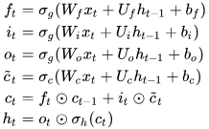

Figure 1 LSTM With Forget Gate

**Peephole LSTM**

The figure on the right is a graphical representation of an LSTM unit with peephole connections (i.e., a peephole LSTM). Peephole connections allow the gates to access the constant error carousel (CEC), whose activation is the cell state.

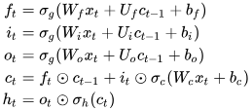

Figure 2 Peephole LSTM

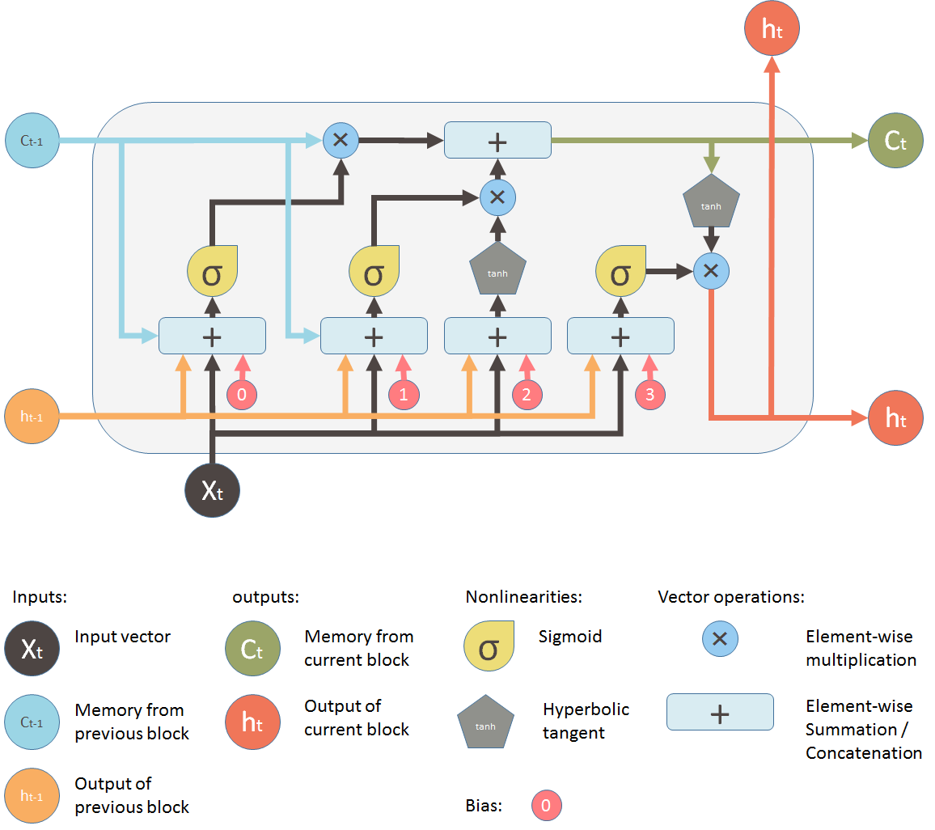

Figure 3 LSTM Architecture

* **Batch Normalization**

Batch normalization (also known as batch norm) is a method used to make training of artificial neural networks faster and more stable through normalization of the layers' inputs by re-centring and re-scaling. It was proposed by Sergey Ioffe and Christian Szegedy in 2015.

While the effect of batch normalization is evident, the reasons behind its effectiveness remain under discussion. It was believed that it can mitigate the problem of internal covariate shift, where parameter initialization and changes in the distribution of the inputs of each layer affect the learning rate of the network. Recently, some scholars have argued that batch normalization does not reduce internal covariate shift, but rather smooths the objective function, which in turn improves the performance. However, at initialization, batch normalization in fact induces severe gradient explosion in deep networks, which is only alleviated by skip connections in residual networks. Others maintain that batch normalization achieves length-direction decoupling, and thereby accelerates neural networks.

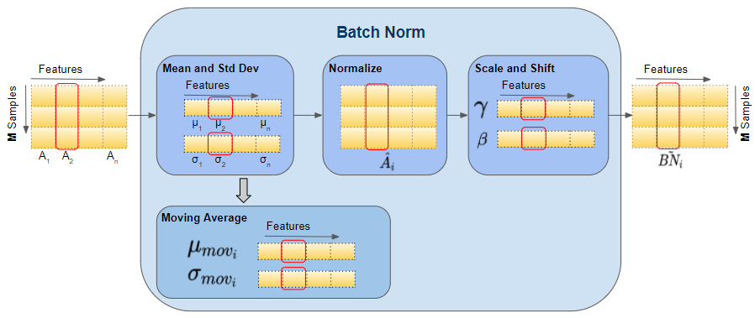

Figure 4 Batch Normalization

* **Early Stopping**

In machine learning, early stopping is a form of regularization used to avoid overfitting when training a learner with an iterative method, such as gradient descent. Such methods update the learner so as to make it better fit the training data with each iteration. Up to a point, this improves the learner's performance on data outside of the training set. Past that point, however, improving the learner's fit to the training data comes at the expense of increased generalization error. Early stopping rules provide guidance as to how many iterations can be run before the learner begins to over-fit. Early stopping rules have been employed in many different machine learning methods, with varying amounts of 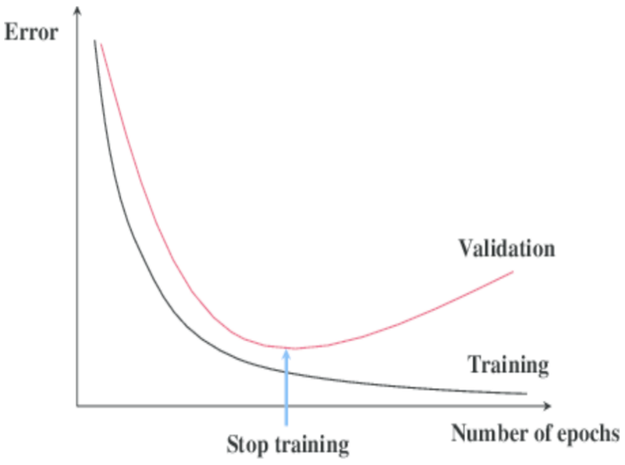theoretical foundation.

Figure 5 Early Stopping

* **Adam Optimizer**

Adam, short for Adaptive Moment Estimation, is an optimization algorithm commonly used for training deep learning models. It combines ideas from two other popular optimization algorithms: RMSprop (Root Mean Square Propagation) and Momentum. Adam is known for its efficiency, effectiveness, and adaptability to different types of neural network architectures. Below are key aspects and characteristics of the Adam optimization algorithm.

Momentum: Adam incorporates the concept of momentum, which helps accelerate the optimization process. Momentum is a moving average of gradients, and it helps the optimizer persist in the correct direction even when gradients are noisy or sparse.

RMSprop: Adam also utilizes the RMSprop technique, which adapts the learning rates for each parameter individually. It maintains a moving average of the squared gradients, and the learning rates are scaled by the inverse square root of these moving averages. This helps handle uneven magnitudes of gradients across different parameters.

The algorithm involvesinitializing the first and second moments (m and v) to zero. Compute the gradients of the objective function with respect to the model parameters. Update the exponentially decaying moving averages of gradients m and squared gradients. Correct the bias introduced by the initialization of m and v at the beginning by dividing them by 1 - beta1^t n 1 - beta_2^t, where t is the iteration step. Update the model parameters using the computed moments and the learning rate.

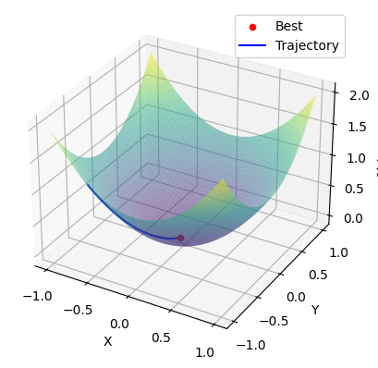

Figure 6 Adam Optimizer

* **RMSProp**

RMSProp, root mean square propagation, is an optimization algorithm/method designed for Artificial Neural Network (ANN) training. And it is an unpublished algorithm first proposed in the Coursera course. “Neural Network for Machine Learning” lecture six by Geoff Hinton. RMSProp lies in the realm of adaptive learning rate methods, which have been growing in popularity in recent years because it is the extension of Stochastic Gradient Descent (SGD) algorithm, momentum method, and the foundation of Adam algorithm. One of the applications of RMSProp is the stochastic technology for mini-batch gradient descent.

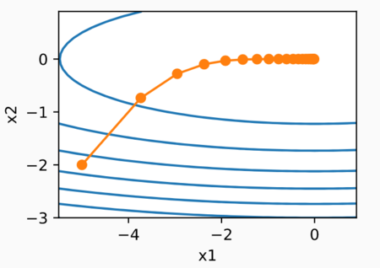

Figure 7 RMSprop Optimizer

* **Dropout Layers**

Dropout is a regularization technique used in neural networks to prevent overfitting. It was introduced by Geoffrey Hinton, Nitish Srivastava, Alex Krizhevsky, Ilya Sutskever, and Ruslan Salakhutdinov in their paper titled "Dropout: A Simple Way to Prevent Neural Networks from Overfitting." Dropout is implemented by randomly setting a fraction of input units to zero during training. This helps to prevent complex co-adaptations on training data and, in turn, improves the generalization of the model to new, unseen data. Here are the key points to understand about dropout layers:

**Mechanism**

During training, each node (or neuron) in the dropout layer has a probability \(p\) of being "dropped out" or deactivated. This means that the output of that node is set to zero, effectively removing it from the network for that particular training iteration.

The stochastic nature of dropout introduces noise into the learning process. This helps prevent the model from relying too much on specific input features or neurons, making it more robust and less likely to overfit. In neural networks, dropout is typically implemented as a Dropout layer. This layer is added to the architecture during the training phase and removed during testing or inference. The dropout rate is a hyperparameter that determines the probability of dropping out a neuron. Common dropout rates range from 0.2 to 0.5, but the optimal value may depend on the specific architecture and dataset.

Dropout serves as a form of regularization by preventing the co-adaptation of neurons. It helps prevent overfitting, especially in deep neural networks with a large number of parameters. Dropout can be viewed as training an ensemble of multiple models, each with a subset of neurons. This ensemble effect can improve the generalization performance of the model.

Dropout reduces the reliance of the model on specific features, making it less sensitive to noise and outliers in the training data. Dropout is a powerful regularization technique that helps prevent overfitting in neural networks by introducing stochasticity during training. Its ease of implementation and effectiveness make it a widely used tool in the deep learning community.

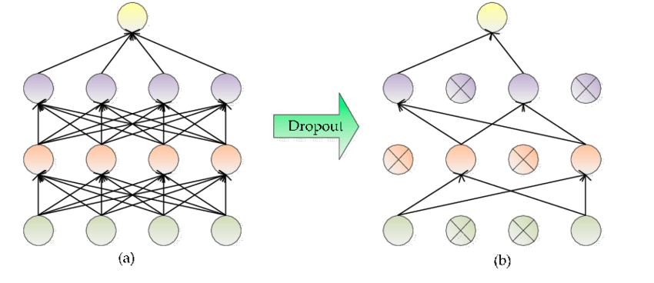

Figure 8 Dropout Layers

* **L1 & L2 Regularizer**

The L1 regularizer, commonly known as Lasso (Least Absolute Shrinkage and Selection Operator) regularization, is a technique applied in machine learning to mitigate overfitting and encourage sparsity in learned models. When incorporated into the training process, the L1 regularizer adds a penalty term to the standard cost function. This additional term is proportional to the sum of the absolute values of the model parameters, weighted by a regularization parameter lambda.

The key characteristic of L1 regularization is its tendency to induce sparsity in the model. By adding the absolute values of parameters to the cost function, L1 regularization encourages some parameters to become exactly zero. This results in a form of automatic feature selection, where irrelevant or redundant features have associated zero coefficients, simplified the model and enhanced interpretability.

L1 regularization is particularly useful in situations where there are many features, and not all of them are relevant to the task at hand. Its ability to perform feature selection makes it valuable in high-dimensional datasets, contributing to improved generalization performance.

During the training process, the regularization parameter lambda plays a crucial role in balancing the fit to the training data and the simplicity of the model. Cross-validation or other tuning techniques are often employed to find an optimal value for lambda that suits the specific learning task.

In summary, L1 regularization, or Lasso regularization, is a regularization technique that helps prevent overfitting and encourages sparsity in machine learning models. Its ability to perform automatic feature selection makes it a valuable tool, especially in scenarios with high-dimensional data. The L2 regularizer, also known as Ridge regularization, is a technique employed in machine learning to address overfitting and promote generalization in trained models. In the context of training algorithms, L2 regularization involves adding a penalty term to the standard cost function. This supplementary term is proportional to the squared magnitudes of the model parameters, scaled by a regularization parameter lambda.

Unlike L1 regularization, L2 regularization does not induce sparsity in the model. Instead, it penalizes large parameter values and effectively discourages the model from assigning overly high weights to any particular feature. This can be advantageous in situations where most features are expected to contribute to the prediction task, but excessive weights may lead to overfitting. The regularization parameter lambda plays a critical role in the L2 regularization process, balancing the trade-off between fitting the training data well and maintaining a simple model. This parameter is often tuned using techniques such as cross-validation to achieve optimal model performance.

L2 regularization is commonly applied in linear regression models and is particularly valuable when dealing with multicollinearity, where predictor variables are correlated. By penalizing large coefficients, L2 regularization helps stabilize the training process and can lead to better generalization to new, unseen data.

In summary, L2 regularization, or Ridge regularization, is a regularization technique used to prevent overfitting in machine learning models. It achieves this by penalizing large parameter values, promoting a more stable and generalized model. The regularization parameter lambda is a key factor in controlling the strength of regularization.

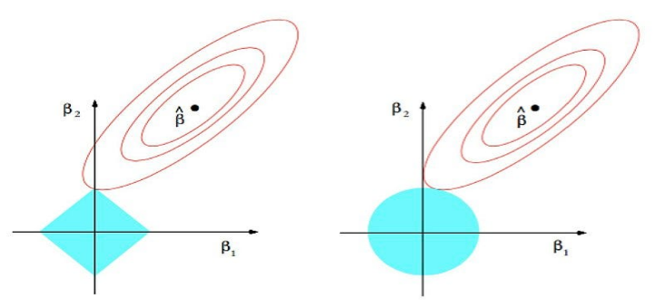

Figure 9 L1 & L2 Regularization

1. **MODEL PREPARATION**

LSTM architecture was chosen and put into practice. For analysing the models' effectiveness, the dataset was divided into training and testing sets.

* **LSTM:** LSTM was employed on the sign dataset to detect words for the sign shown. The model achieved an accuracy of 98.3%, indicating its ability to correctly detect the signs for a significant portion of the dataset. However, accuracy alone is not a comprehensive evaluation measure, and further metrics such as precision, recall, confusion matrix and F1-score should be considered. The model's performance can be enhanced through parameter tuning and the use of more advanced algorithms.

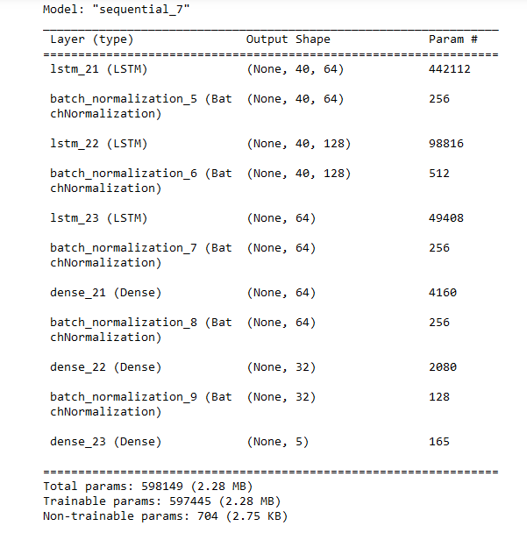

Figure 10 LSTM Model Report

1. **EVALUATION**

To evaluate the performance of the models, evaluation metrics like F1 Score, Confusion matrix are used.

* **F1 Score**: F1 score is a machine learning evaluation metric that measures a model’s accuracy. It combines the precision and recall scores of a model. The accuracy metric computes how many times a model made a correct prediction across the entire dataset. This can be a reliable metric only if the dataset is class-balanced; that is, each class of the dataset has the same number of samples. Nevertheless, real-world datasets are heavily class-imbalanced, often 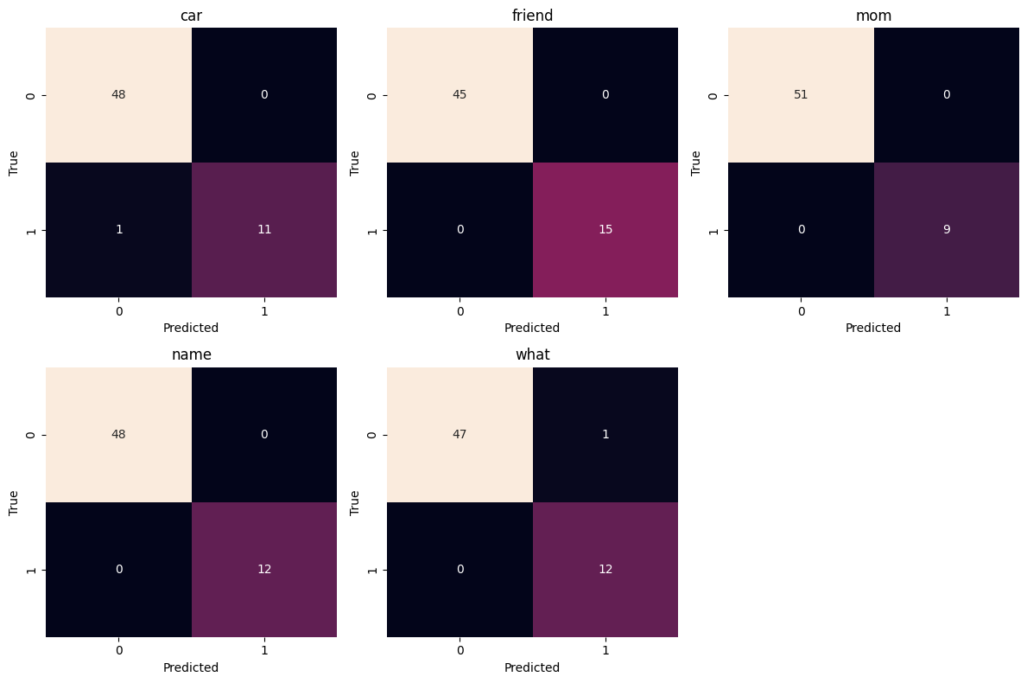making this metric unviable. For example, if a binary class dataset has 90 and 10 samples in class-1 and class-2, respectively, a model that only predicts “class-1,” regardless of the sample, will still be 90% accurate. Accuracy computes how many times a model made a correct prediction across the entire dataset. However, can this model be called a good predictor? This is where the F1 score comes into play. We will investigate the mathematical explanation behind the metric in the next section but let us first understand the precision and recall in relation to a binary class dataset with classes labelled “positive” and “negative.” Precision measures how many of the “positive” predictions made by the model were correct. Recall measures how many of the positive class samples present in the dataset were correctly identified by the model.
* **Confusion Matrix**: The confusion matrix is a matrix used to determine the performance of the classification models for a given set of test data. It can only be determined if the true values for test data are known. The matrix itself can be easily understood, but the related terminologies may be confusing. Since it shows the errors in the model performance in the form of a matrix, hence also known as an error matrix. Here are all the model evaluations,

Figure 11 ‘Car’ Confusion Matrix

****Figure 12 ‘Friend’ Confusion Matrix

Figure 13 'Mom' Confusion Matrix

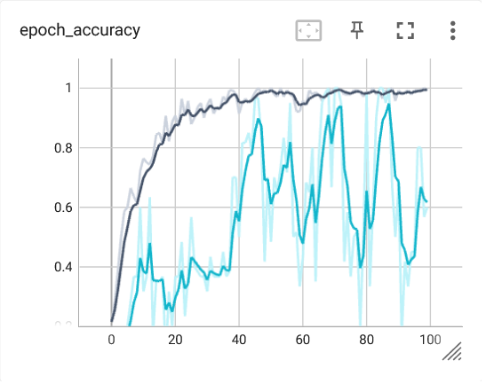

Figure 14 ‘Name’ Confusion Matrix

**

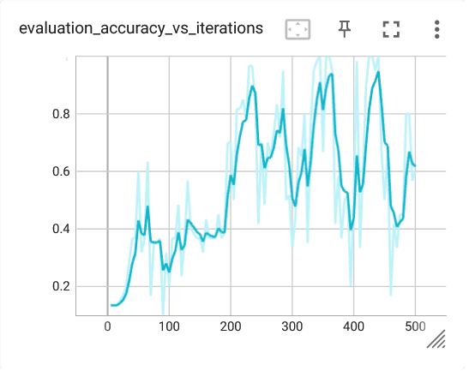Figure 15 ‘What’ Confusion Matrix

1. **RESULT**

|  |  |
| --- | --- |
| Words’ Accuracy (F1 Scores) | |
| Car | 98.9% |
| Friend | 100% |
| Mom | 100% |
| Name | 100% |
| What | 98.9% |

*****Chart: Categorical accuracies & F1 Scores*

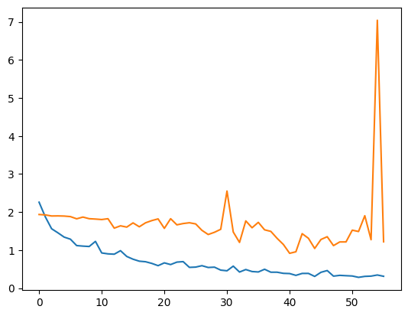

Figure 16 Training (Blue) & Validation (Orange) Loss [loss vs epoch graph]

Figure 17 Training (Dark Blue) vs Validation (Blue) Accuracy [accuracy vs epoch graph]

Figure 18 Validation Accuracy [accuracy vs epoch graph]

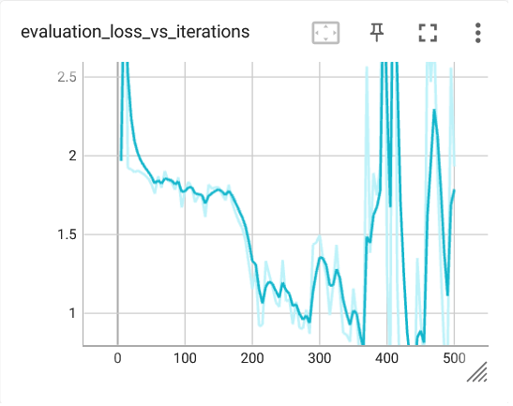

Figure 19 Validation Loss [loss vs epoch graph]

1. **FLOWCHART**

The Data flowchart is also called a bubble chart. It is a simple graphical formalism that can be used to represent a system in terms of input data to the system, various processing carried out on this data, and the output data is generated by this system.

The data flow chart is one of the most important modelling tools. It is used to model the system components. These components are the system process, the data used by the process, an external entity that interacts with the system and the information flows in the system.

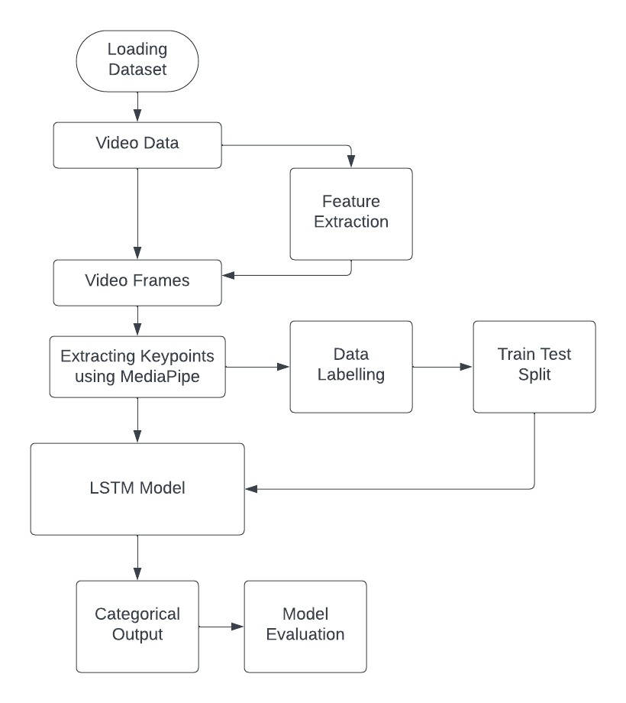

Figure 20 Model Flowchart

1. **MODEL DEPLOYMENT**

**CATEGORICAL OUTPUT**

In this project, we have used Flask, a Python module created exclusively for building python web applications. Flask is a popular Python web framework that simplifies the process of building web applications. It provides a lightweight and flexible approach to developing web services and APIs. Flask is often referred to as a microframework because it focuses on simplicity and minimalism. It provides only the essential tools and features needed to build web applications, allowing developers to have more control and flexibility over their project structure and dependencies. Flask uses a routing mechanism that maps URLs to specific functions or view handlers. This allows you to define different routes for different parts of your application and handle various HTTP methods (GET, POST, etc.) accordingly. Routing in Flask is easy to configure and can handle dynamic parameters in URLs. Flask includes a powerful template engine called Jinja2, which allows you to separate the presentation layer from the application logic. With templates, you can dynamically generate HTML pages by embedding variables, loops, conditionals, and other control structures within your HTML code. Flask provides simple and intuitive ways to handle HTTP requests. You can access request data such as form input, query parameters, cookies, and more using the request object. Flask also supports file uploads, allowing you to process files sent by the client. Flask is a lightweight and flexible web framework that empowers developers to build web applications efficiently. It offers essential features for routing, request handling, response generation, template rendering, URL building, and more. Flask's simplicity, modularity, and extensibility make it a popular choice for developing web services and APIs.

The snapshots of the deployed model are displayed in the accompanying images:

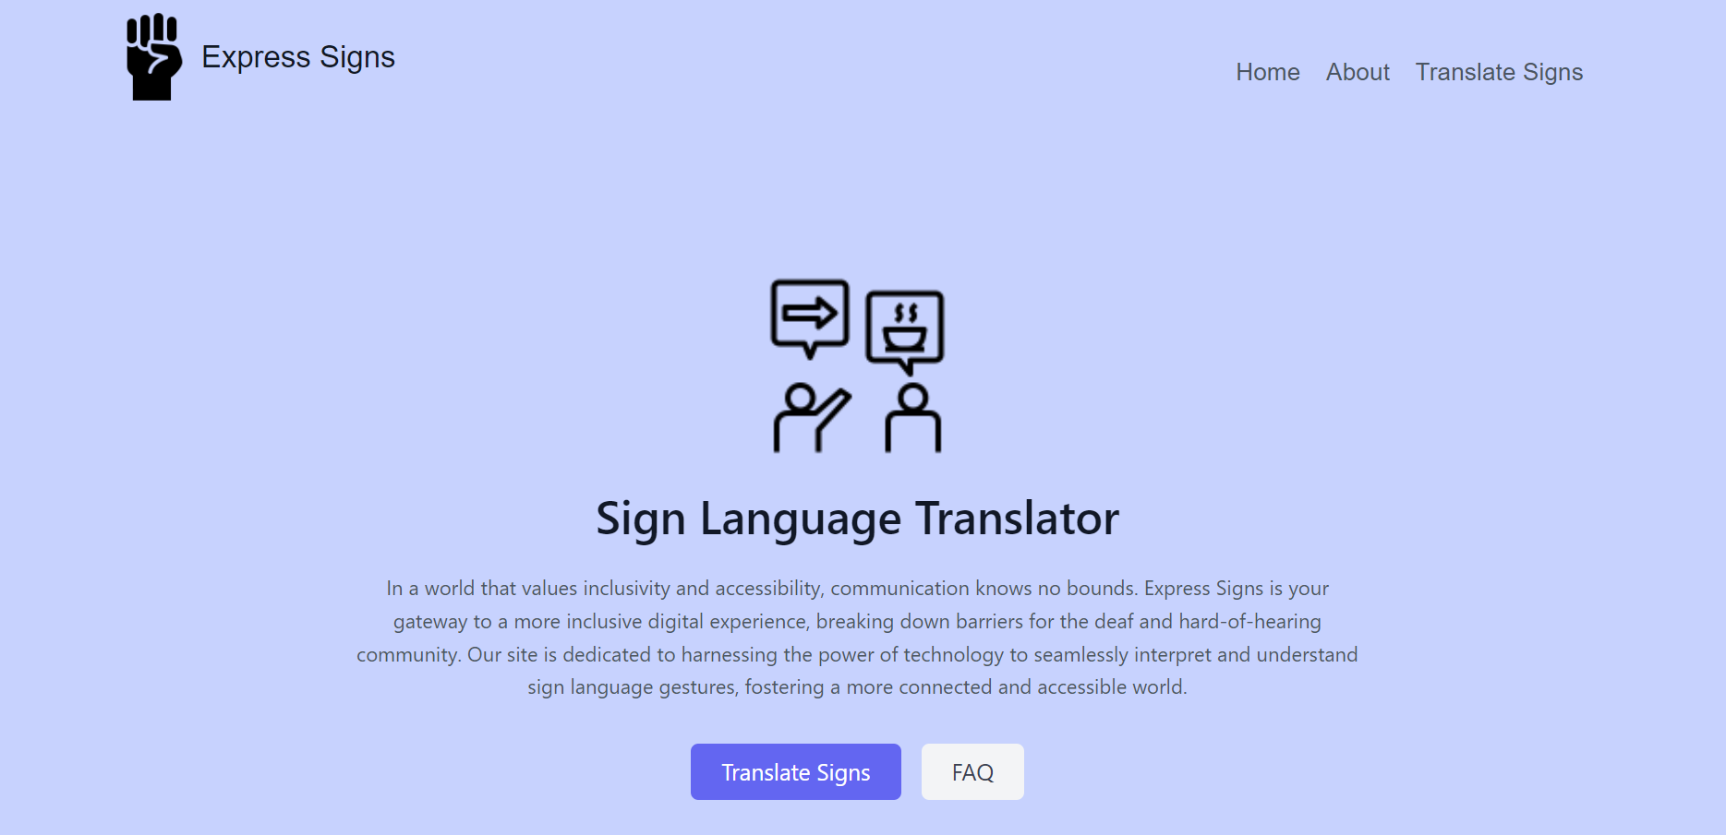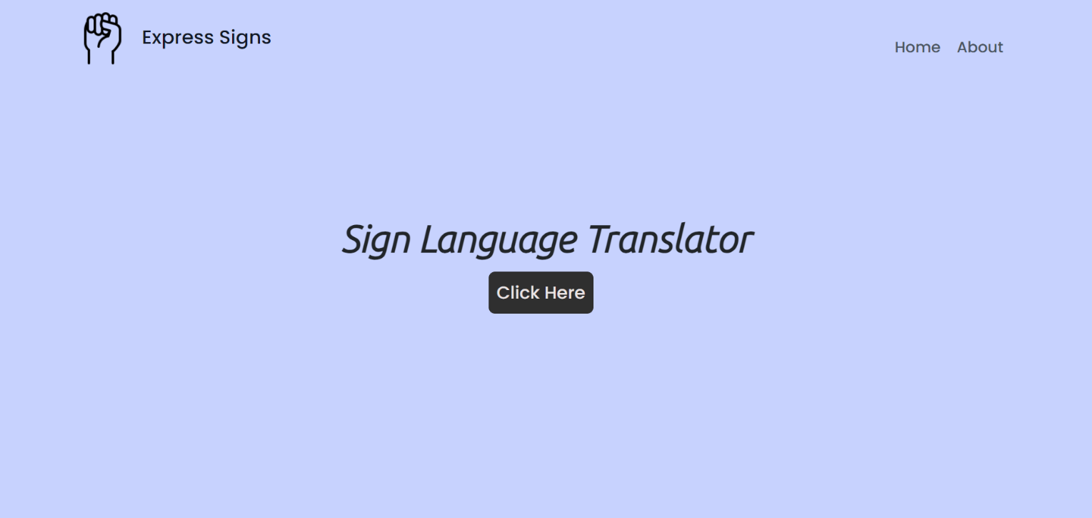

Figure 21 Model deployment: Homepage

Figure 22 Model deployment: Check page

1. **CONCLUSION**

The Sign Language Detection model represents a significant advancement in bridging the communication gap for individuals who rely on sign language. This innovative model leverages computer vision techniques, including the use of the ASL dataset, OpenCV, and the MediaPipe library, to accurately interpret and categorize American Sign Language (ASL) gestures in real-time.

In summary, the Sign Language Detection model is a testament to the power of technology in fostering inclusivity and improving the lives of individuals within the deaf and hard-of-hearing community. As advancements continue, the model stands as a meaningful contribution to the field of assistive technologies and human-computer interaction

1. **FUTURE WORK**

In future, we will add more set of signs to the model. It will help model to capture more signs of ASL. We will also intend to add more quality data to the model to increase its efficiency and performance of the model. We hope to make it more generalize, so that it can be used in the real-world applications.

1. **REFERENCES**

[1] Mahdi Abavisani, Hamid Vaezi Joze, and VM Patel. Improving the performance of unimodal dynamic hand-gesture recognition with multimodal training. Proceedings of the IEEE Conference on Computer Vision and Pattern Recognition, 2019.

[2] Vassilis Athitsos, Carol Neidle, Stan Sclaroff, Joan Nash, Alexandra Stefan, Quan Yuan, and Ashwin Thangali. The american sign language lexicon video dataset. In Computer Vision and Pattern Recognition Workshops, 2008. CVPRW’08. IEEE Computer Society Conference on, pages 1–8. IEEE, 2008.

[3] Annelies Braffort, Laurence Bolot, Emilie Chételat-Pelé, Annick Choisier, Maxime Delorme, Michael Filhol, Jérémie Segouat, Cyril Verrecchia, Flora Badin, and Nadège Devos. Sign Language Corpora for Analysis, Processing and Evaluation. In Proc. Int. Conf. on Language Resources and Evaluation (LREC), pages 453–456, Valletta, Malta, May 2010. ELRA.

[4] Helene Brashear, Thad Starner, Paul Lukowicz, and Holger Junker. Using multiple sensors for mobile sign language recognition. Georgia Institute of Technology, 2003.

[5] Cihan Camgoz, Simon Hadfield, Oscar Koller, Hermann Ney, and Richard Bowden. Neural Sign Language Translation. In Proc. IEEE Conf. on Computer Vision and Pattern Recognition (CVPR), pages 7784–7793, Salt Lake City, UT, June 2018.

[6] Necati Cihan Camgoz, Simon Hadfield, Oscar Koller, and Richard Bowden. Using Convolutional 3D Neural Networks for User-Independent Continuous Gesture Recognition. In Proc. Int. Conf. on Pattern Recognition Workshops (ICPRW), pages 49–54, Cancun, Mexico, December 2016.

[7] Necati Cihan Camgoz, Ahmet Alp Kindiroglu, Serpil Karabuklu, Meltem Kelepir, Ayse Sumru Ozsoy, and Lale Akarun. BosphorusSign: A Turkish Sign Language Recognition Corpus in Health and Finance Domains. In Proc. Int. Conf. on Language Resources and Evaluation (LREC), pages 1383–1388, May 2016.

[8] Pavel Campr, Marek Hrúz, and Jana Trojanová. Collection and preprocessing of czech sign language corpus for sign language recognition. In Proc. Int. Conf. on Language Resources and Evaluation (LREC), pages 3175–3178, May 2008.

[9] Zhe Cao, Tomas Simon, Shih-En Wei, and Yaser Sheikh. Realtime multi-person 2d pose estimation using part affinity fields. In CVPR, 2017.

[10] Joao Carreira and Andrew Zisserman. Quo vadis, action recognition? a new model and the kinetics dataset. In Computer Vision and Pattern Recognition (CVPR), 2017 IEEE Conference on, pages 4724–4733. IEEE, 2017.

[11] Naomi K. Caselli, Zed Sevcikova Sehyr, Ariel M. Cohen-Goldberg, and Karen Emmorey. ASLLEX: A lexical database of American Sign Language. Behavior Research Methods, 49(2):784– 801, April 2017. ISSN 1554-3528. doi: 10.3758/s13428-016-0742-0.

[12] Xiujuan Chai, Hanjie Wang, and Xilin Chen. The DEVISIGN Large Vocabulary of Chinese Sign Language Database and Baseline Evaluations. Technical report, Key Lab of Intelligent Information Processing of Chinese Academy of Sciences, 2014. 00000.

[13] C. Charayaphan and A. E. Marble. Image processing system for interpreting motion in American Sign Language. Journal of Biomedical Engineering,

14(5):419–425, September 1992. ISSN 0141-5425. doi: 10.1016/0141-5425(92)90088-3. [14] Vasileios Choutas, Philippe Weinzaepfel, Jérôme Revaud, and Cordelia Schmid. Potion: Pose motion representation for action recognition. In CVPR 2018, 2018

[15] H. Cooper, N. Pugeault, and R. Bowden. Reading the signs: A video based sign dictionary. In Proc. IEEE Int. Conf. on Computer Vision Workshops (ICCVW), pages 914–919. IEEE, November 2011. doi: 10.1109/ICCVW.2011.6130349.

[16] Helen Cooper and Richard Bowden. Sign Language Recognition using Linguistically Derived Sub-Units... In LREC Workshop on the Representation and Processing of Sign Languages, pages 57–61, Valletta, Malta, 2010.

[17] R. Cui, H. Liu, and C. Zhang. A Deep Neural Framework for Continuous Sign Language Recognition by Iterative Training. IEEE Transactions on Multimedia, 0:1–1, 2019. ISSN 1520-9210. doi: 10.1109/TMM.2018.2889563.

[18] Runpeng Cui, Hu Liu, and Changshui Zhang. Recurrent Convolutional Neural Networks for Continuous Sign Language Recognition by Staged Optimization. In Proc. IEEE Conf. on Computer Vision and Pattern Recognition (CVPR), pages 7361–7369, Honolulu, HI, USA, July 2017.

[19] Jia Deng, Wei Dong, Richard Socher, Li-Jia Li, Kai Li, and Li Fei-Fei. Imagenet: A large-scale hierarchical image database. In Computer Vision and Pattern Recognition, 2009. CVPR 2009. IEEE Conference on, pages 248–255. Ieee, 2009.

[20] Jeffrey Donahue, Lisa Anne Hendricks, Sergio Guadarrama, Marcus Rohrbach, Subhashini Venugopalan, Kate Saenko, and Trevor Darrell. Long-term recurrent convolutional networks for visual recognition and description. In Proceedings of the IEEE conference on computer vision and pattern recognition, pages 2625–2634, 2015.